**Team Mercury – Bletchley Battleships Game – QA Documentation**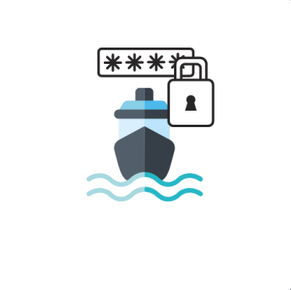

Contents

1. Topic 1

2. Roles 1

3. Summary 2

3.1. Purposes 2

3.2. Used tools 2

3.3. Conclusion 2

# Topic

The topic of the project is a game developed by the programming language C++.

It is about

# Roles

* Scrum trainer – Alexander Yanev, e-mail: azyanev18@codingburgas.bg
* Quality Assurance (QA) – Yavor Karakolev, e-mail: [yakarakolev18@codingburgas.bg](mailto:yakarakolev18@codingburgas.bg)
* Front-end developer – Stephan Stratev, e-mail: [sdstratev18@codingburgas.bg](mailto:sdstratev18@codingburgas.bg)
* Second Front-end developer – Nevena Pavlova, e-mail: nspavlova18@codingburgas.bg
* Back-end developer – Teodor Angelov, e-mail: [ttangelov18@codingburgas.bg](mailto:ttangelov18@codingburgas.bg)
* Code checker – Kaloyan Dimov, e-mail: [kddimov18@codingburgas.bg](mailto:kddimov18@codingburgas.bg)

# Summary

## Purposes

Our purposes are to make a user-friendly product with innovative interface, which is helpful for kids to develop their brains and decrypting skills and also to stimulate their interest to programming which is very important for them.

## Used tools

For developing, we used the programming language C++. For writing the documentation, we used Microsoft Word for the presentation – PowerPoint, for the Test Cases Excel, and last but not least, we used GitHub to share the project between us.

## Conclusion

In conclusion, we realized that making projects require creativity and pleasure to do it Also we realized that we had to be well-organized. I think we did a good job though, but we can do more in the future. Also, we made a good friendship, because we had time to get to know each other.